HR Turnover Analysis

**Wireframe Documentation**

Author: Pawan Nagar

## Homepage

As per the problem statement, we have divided analysis into three sections: -

**1 Some Tiles for Quick Analysis:**

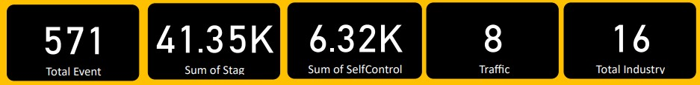

In this section of dashboard, we tried to interpret the followings:-

* + First tile show that total event.
  + Second tile show that sum of stag.
  + Third tile show sum of Self-control.
  + Fourth tile show total count of Traffic.
  + Fifth tile show total industry.

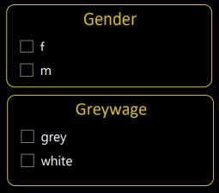**2** **Filters Of Dashboard**

* + Gender section represent type of Gender: - Male(M) and Female(F)
  + Greywage Section represent: - Grey and White
  + 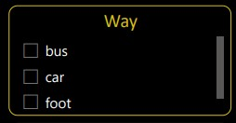Way Section represent: - Travel Way

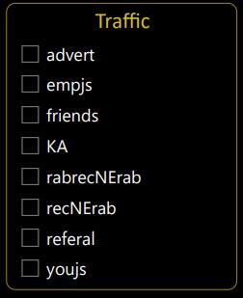

* + Traffic Section represent Like This(Some Data in Different Language-Russian)

**3**. **Gender Based Analysis Visuals**

Here, we have our Dashboard interpret as follow: -

* Coach by Gender
* Total Gender Use traffic and Way

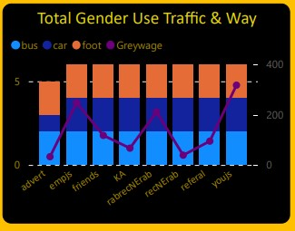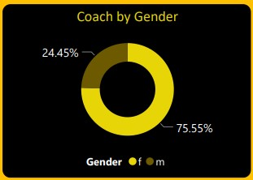

**4 Industry Based Analysis Visuals**

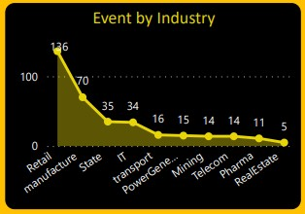

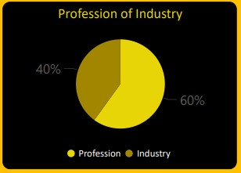

* Relation between Industry and Profession
* Relation between Event and Industry

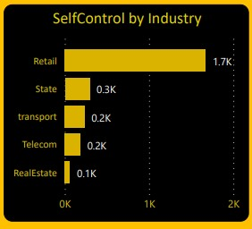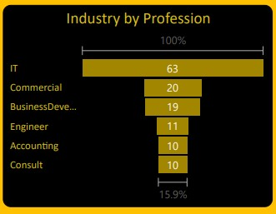

* Relation between Industry and Profession
* Relation between Self-Control and Industry